EE 255 – ELECTRICAL INSTALLATION, TESTING, AND INSPECTION

SAMARAKOON S.M.O.T.

E/21/345

GROUP EE.21.B.23

SEMESTER 04

22.05.2025

**EE 255: ELECTRIC POWER**

**Experiment:** **Electrical Installation, Testing, and Inspection**

# Installation Details

In this experiment, you will use the electrical installation shown in the following figure. It consists of the following circuits:

* + Circuit 1: A radial lamp circuit.
  + Circuit 2: A ring socket outlet circuit.



Figure 01: Installation Setup

* Connect Circuits 1 and 2 and show your circuit to the instructor.
* Test the circuits and then disconnect the main supply to the distribution board (DB).

Table 01: Installation Details

|  |  |  |  |  |  |  |  |
| --- | --- | --- | --- | --- | --- | --- | --- |
|  | | Protective Device | | | | Conductor details | |
| Overload and S/C protection | | | RCD |
| Circuit No | Circuit description | Fuse (F) or MCB (M) | Type | Rating (A) | Residual Current  (mA) | Live (mm2) | CPC (mm2) |
| 1 | A radial lamp circuit | M | C | 6 | 30 | 1 | - |
| 2 | A ring socket outlet circuit | M | C | 32 | 30 | 2.5 | 2.5 |

Data:

* Resistances of different sizes of wires at 20 oC are: 1 mm2 = 18 mΩ/m; 1.5 mm2 = 12 mΩ/m; and 2.5 mm2 = 7 mΩ/m
* The temperature coefficient of resistance at 20 oC is 0.004, and the temperature inside the building is 30 oC.
* Temperature at any temperature (t) is given by Rt = [1 + 0.004(t-20)]R20.
* Assume that the length of each line section connecting socket outlets is 0.5 m.

# Initial certification of a new installation

## ***Continuity of the protective conductor***

Purpose of this test:

This test is carried out to ensure that the equipotential bonding conductors are unbroken and have a resistance low enough to ensure that, under fault conditions, a dangerous potential will not occur between exposed conductive parts.

Test procedure:

Make a **temporary link** between the neutral and protective conductor (earth) of **Circuit 2** in the distribution board.

Step 1: Calculate the resistance between earth and neutral at each socket

Step 2: Measure the resistance between earth and neutral at each socket.

Table 02: Calculated and measured resistance between earth and neutral

|  |  |  |  |  |
| --- | --- | --- | --- | --- |
| At the socket outlet | | 1 | 2 | 3 |
| Resistance between earth and neutral (Ω) | Calculated | 0.007644 | 0.0091 | 0.007644 |
| Measured | 0.4 | 0.5 | 0.7 |

Fill in Table A2 in the Appendix. The reading taken at socket outlet 3 will be (R1 + R2).

Continuity test on protective conductor: Pass  Fail

**\*\**Remove the temporary connection***

Comment on the result

|  |
| --- |
| As we can see protective conductor has low resistance as we expected. Ideally, we expected resistance to be zero, still the value we got for resistance is sufficiently low that pass the test ensuring the resistance lower than agreed standard. |

## ***Continuity of the ring circuit***

Purpose of this test:

The purpose of this test is to ensure that the cables form a complete ring; there are no interconnections, and the polarity is correct on all socket outlets.

Test procedure:

* Disconnect the two ends of the ring cables (phase, neutral and earth) at the DB. Name them as L1, L2, N1, N2, E1 and E2.



Figure 02: Test setup

* Connect L1 and N2 using a **temporary link**
* Calculate the resistance between N1 and L2
* Measure the resistance between N1 and L2

Table 03 : Calculated and measured resistance between N1 and L2

|  |  |
| --- | --- |
| R_N1L2 Calculated (Ω) | 0.02912 |
| R_N1L2 Measured (Ω) | 1.1 |

* Connect L1 and N2 as well as L2 and N1.
* Calculate the resistance between L and N at each socket outlet
* Fill in the following table (RLN)

Table 04: Calculated and measured resistance between live and neutral

|  |  |  |  |
| --- | --- | --- | --- |
| At the socket outlet | 1 | 2 | 3 |
| RLN calculated (Ω) | 0.00728 | 0.00728 | 0.00728 |
| RLN measured (Ω) | 0.6 | 0.7 | 0.8 |

* Connect L1 and E2 as well as L2 and E1.
* Calculate the resistance between L and E at each socket outlet
* Measure the resistance between L and E at each socket outlet
* Fill in the following table (RLE)

Table 05: Calculated and measured resistance between earth and live

|  |  |  |  |
| --- | --- | --- | --- |
| At the socket outlet | 1 | 2 | 3 |
| RLE calculated (Ω) | 0.00728 | 0.00728 | 0.00728 |
| RLE measured (Ω) | 0.4 | 0.4 | 0.5 |

Continuity test on phase–neutral: Pass Fail

Comment on the results for each test.

|  |
| --- |
| This test is performed to ensure that cables form a full ring. As we can see, there is a slight difference between calculated value and the measured value. Measured value is slightly higher than that of calculated. Potential reasons maybe the unaccounted resistances like resistances at connection points and assumption of length of each wire is 0.5m. |

***Reconnect the cables to form the ring circuit.***

## ***Insulation resistance***

Purpose of this test:

The purpose of this test is to check whether there is likely to be any leakage of current through the insulated parts of the installation.

Test procedure:

Before conducting the test, ensure that all protective devices are in place and switched ON, and remove all lamps from fittings where accessible. When testing the whole installation from the disconnected tails, the main switch must be in the ON position.

* Measure the insulation resistance between Live and Neutral conductors by supplying **500 V DC**.
* Connect Live and Neutral conductors together and measure the insulation resistance to the protective conductor.

Table 06: Insulation test observations

|  |  |  |  |
| --- | --- | --- | --- |
|  | Minimum value as per BS7571:2008 | Measured insulation resistance | Test Pass/Fail |
| Between Live and Neutral conductors | 1 MΩ | 100MΩ | Pass |
| Between Live + Neutral conductor and the protective conductor | 1 MΩ | 30 MΩ | Pass |

***If it is necessary to test individual circuits, the same process can be applied to new and existing circuits, and the same safety precautions must be taken.***

**Fill in the following table, which is prepared as per the generic schedule of test results as per BS 7671:2018**

Table 07: Summary of test results

|  |  |  |  |  |  |  |  |  |
| --- | --- | --- | --- | --- | --- | --- | --- | --- |
|  | | Ring final circuit continuity (Ω) | | | Continuity  (R1 + R2) or R2 (Ω) | | Insulation Resistance (MΩ) | |
|
| Circuit No | Circuit description | R_L1N1 | Maximum of RLN | Maximum of RLE | R1 + R2 | R2 | Live - Neutral | Live - Earth |
| 1 | A radial lamp circuit |  | | |  | | 100 | - |
| 2 | A ring socket outlet circuit | 1.1 | 0.8 | 0.5 | 0.7 | - | 100 | 30 |

## ***Polarity test***

Purpose of this test:

This is a test carried out to ensure that the protective devices are connected to the phase conductors of the circuits that they are protecting, and switches in the circuits are in the phase conductors.

Test procedure:

Remove any consumer device connected to the circuit. Connect one end of the low-resistance meter to the phase conductor at the DB. The other end of the meter should be connected to the expected live terminal of the socket, holder, or any other device terminating point. Measure the resistance and record it.

*Socket outlet circuit:*

Resistance readings when the switch is ON: ………0.4 Ω ……………………………

Resistance readings when the switch is OFF: ………∞……………………………

Polarity test: Pass Fail

If it fails, interchange L and N in the socket and repeat the test.

Resistance readings: ………-……………………………………………………………….

Polarity test: Pass Fail

*One lighting circuit:*

Resistance readings when the switch is ON: ………0.5 Ω ……………………………

Resistance readings when the switch is OFF: ………∞………………………………

Polarity test: Pass  Fail

If it fails, interchange L and N at the holder and repeat the test.

Resistance readings: ………………………………………………………………………..

Polarity test: Pass  Fail

Comment on the results

|  |
| --- |
| As we observed all tests passed. When switch is on it showed low resistance value, meanwhile when it turned of indicated infinite resistance. Which means all connections are continuous when they are switched on. |

# Tests after connection of the supply

## ***Testing the earth electrode***

Purpose of this test:

This is a test carried out to ensure that the resistance of the earth electrode is small enough to ensure that the voltage on exposed metal parts during a fault is within the acceptable level, and the automatic disconnection equipment disconnects the circuit within 0.2 sec.

Test procedure:

Disconnect the earth electrode from the earthing system of the installation. Two temporary spikes should be driven into the ground as shown in Figure 1. The distance between the earth electrode and the far end spike is 15 m. Connect the earth resistance tester as shown below. Take the reading (R1). Change the location of the auxiliary spike by 1.5 m from the earth electrode to the end electrode and record the resistance values with the distance. Draw the variation of resistance with distance (L) in the grid provided.



Figure 03: Earth resistance tester setup

What is the earth electrode resistance? ……………………3.6Ω…………………………………………

Earth electrode test: Pass  Fail

Read the instructions for the equipment and propose an easy method for this on a site.

|  |
| --- |
| As we calculated the resistance using obtained data and interpolating the curve to find the resistance when the length is 62% from total length, from the calculations obtained the value as 9.3m. So instead of varying the L for many times is tedious and unnecessary. We can straightaway measure the resistance when L is 9.3m. This will give sufficiently accurate value, if we need an approximate value for earth rod |

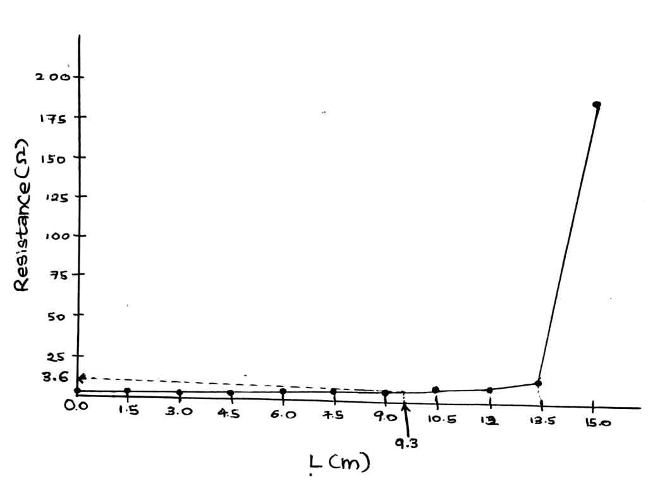

Figure 04: Variation of resistance with distance

## ***Protection by automatic disconnection of the supply***

Purpose of this test:

This test is carried out to test the operation of the RCD.

Test procedure:

Press the test button of the RCD device and see whether it is operational.

Testing RCD device: Pass  Fail

## ***RCD Testing***

Purpose of this test:

This test is carried out to test the operation of the RCD by measuring the trip time using a device.

Test procedure:

Connect the mains plug test lead to the instrument.

Plug in the mains plug test lead to the wall outlet.

Set the top RCD selection knob to the desired range (10mA, 30mA, 100mA, 300mA, 500mA, 1000mA).

Set the RCD test knob to 1/2l, l or 5l as required.

Press the [TEST] button.

Trip time reading for when RCD test knob is set to 1/2I: ……………∞………….

Trip time reading for when RCD test knob is set to I: ………28.5 ms………………

Trip time reading for when RCD test knob is set to 5I: ………6.4 ms……………

RCD Testing: Pass  Fail

## ***Earth Fault Loop Testing***

Purpose of this test:

This test is done to verify that a sufficient current will flow in a fault situation in order to operate the relevant protective device.

Test procedure:

Connect the mains plug test lead to the instrument.

Plug in the mains plug test lead to the wall outlet.

Set the top selection knob to Z and the bottom selection knob to “No trip”.

Press the [TEST] button.

Resistance reading: ……12.1 Ω …………………………………

Fault Current reading: …1.18 A …………………………………………..

Earth Fault Loop Testing: Pass  Fail

TABULATION

Table 08: Distance vs Resistance

|  |  |
| --- | --- |
| Distance(L)/m | Resistance(R)/Ω |
| 0.0 | 0.7 |
| 1.5 | 1.3 |
| 3.0 | 1.5 |
| 4.5 | 1.8 |
| 6.0 | 2.5 |
| 7.5 | 3.0 |
| 9.0 | 3.5 |
| 10.5 | 4.0 |
| 12.0 | 5.5 |
| 13.5 | 9.0 |
| 15.0 | 190.0 |

CALCULATIONS

From Data,

Resistance at 30 oC (Rt ) = [1 + 0.004(t-20)]R20

= [1+ 0.004(30-20)]x7mΩ/m

= 7.28 mΩ/m

Part 2.1

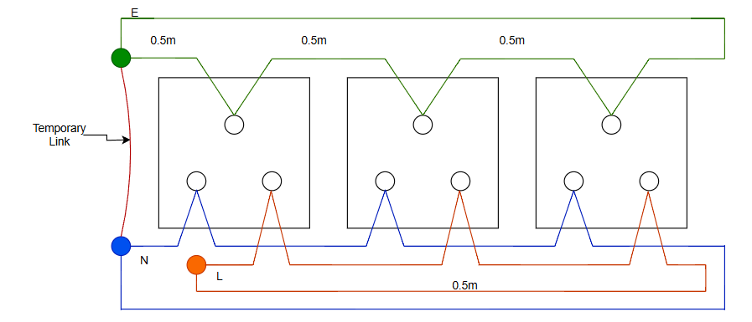

Figure 05: Circuit 2 with a temporary link between neutral and earth

Considering socket outlet 1,

Number of wire segments in the short path = 3

Length of the short path = 3 x 0.5 m

Resistance of the short path = 3 x 0.5 m x 7.28 mΩ/m

= 10.92 mΩ

Number of wire segments in the long path = 7

Length of the long path = 7 x 0.5 m

Resistance of the long path = 7 x 0.5 m x 7.28 mΩ/m

= 25.48 mΩ

Total resistance for socket outlet 1 = 10.92 mΩ // 25.48 mΩ

= 7.644 mΩ

*The value is same for socket outlet 3.

∴ Total resistance for socket outlet 3 = 7.644 mΩ

Considering socket outlet 2,

Number of wire segments in each path = 5

Length of each path = 5 x 0.5 m

Resistance of each path = 5 x 0.5 m x 7.28 mΩ/m

= 18.2 mΩ

Total resistance for socket outlet 2 = 18.2 mΩ // 18.2 mΩ

= 9.1 mΩ

Part 2.2

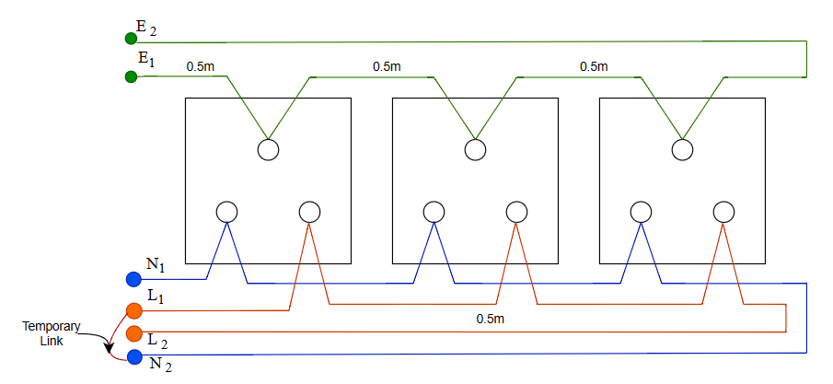

Figure 06 : Disconnected circuit 2 with a temporary link between L1 and N2

After connecting L1 and N2 ,

Number of wire segments in the path = 8

Length of the path = 8 x 0.5 m

Resistance of the path = 8 x 0.5 m x 7.28 mΩ/m

= 29.12 mΩ

After connecting L1 and N2 as well as L2 and N1 ,

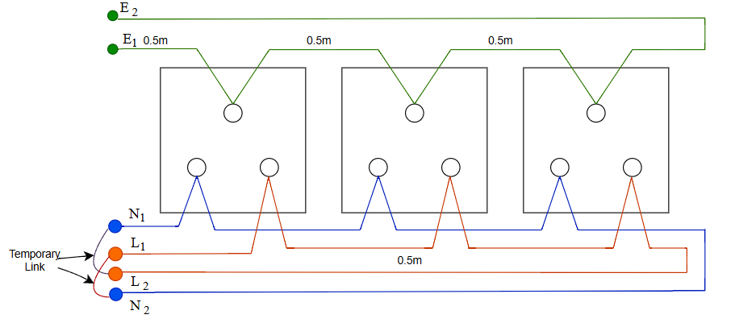

Figure 07 : Disconnected circuit 2 with temporary links between L1 N2 and L2 N1

Number of wire segments in the path = 4

Length of the path = 4 x 0.5 m

Resistance of the path = 4x 0.5 m x 7.28 mΩ/m

= 14.56 mΩ

Total resistance (RLN) = 14.56 mΩ // 14.56 mΩ

= 7.28 mΩ

After connecting L1 and E2 as well as L2 and E1 ,

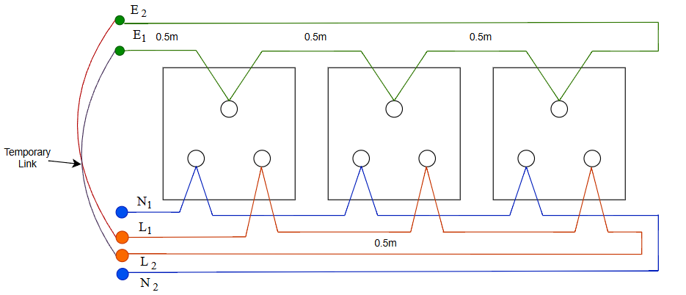

Figure 08 : Disconnected circuit 2 with temporary links between L1 E2 and L2 E1

Since 2.5 mm2 wires are used for all Live, Neutral and Earth wiring, RLE is same as RLN.

Thereforefor each socket outlet,

RLE = 7.28 mΩ

Part 3.1

Distance to 62% point = 15m × 0.62  
 = 9.3 m

Calculating the earth rode resistance using interpolation,

Considering the data points of (9.0, 3.5) and (10.5, 4.0) ,

4.0 – 3.5 = R – 3.5  
 10.5 – 9.0 9.3 – 9.0

R = 3.6Ω

REFERENCES

[1] “Earth resistance testing with Euclid and Da Vinci | Megger,” *Megger.com*, 2023. <https://www.megger.com/en-us/et-online/February-2018/Earth-resistance-testing-with-Euclid-and-Da-Vinci>

Accessed: 17.06.2025 at 3.30pm

[2]John Ward (jwflame), “Earth Electrode Testing,” *YouTube*, Dec. 30, 2016. <https://www.youtube.com/watch?v=G9CjydiUkAI>

Accessed: 17.06.2025 at 3.43pm

[3]“4 Essential Ground Testing Methods,” *www.fluke.com*. <https://www.fluke.com/en/learn/blog/electrical/dont-forget-the-grounding-system>

Accessed: 17.06.2025 at 3.17pm

[4]Installation Diagrams, “Installation Diagrams,” *Google Docs*, 2019. <https://drive.google.com/file/d/1Hqm2gZtpxAygbtIrWHOYee03gprfsH7E/view?usp=sharing>Accessed: 18.06.2025 at 4.15pm

‌

‌

‌

‌